**Veracode and Sonar Plugin in Intellij**

1. **Veracode Setup:**
   1. **First you need to plugin Veracode : Step**

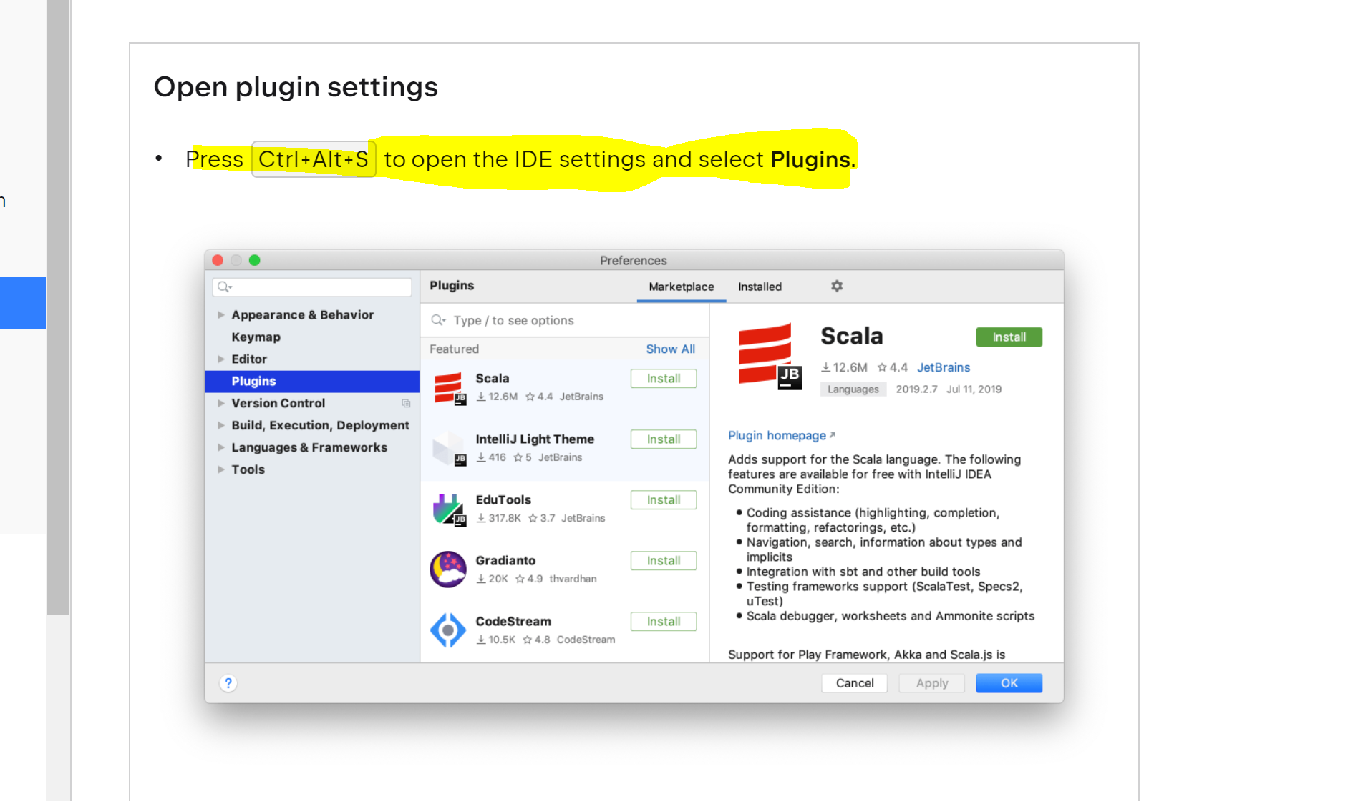

* 1. **Search Veracode**
  2. **Install**
  3. **Restart the Intellij**
  4. **Go to** [**https://myapps.microsoft.com/signin/Veracode/2c824dbc-e775-4f9e-af03-913d363717fb**](https://myapps.microsoft.com/signin/Veracode/2c824dbc-e775-4f9e-af03-913d363717fb)
  5. **And got to Profile 🡪Api Credentials 🡪 generate the API Credentials**

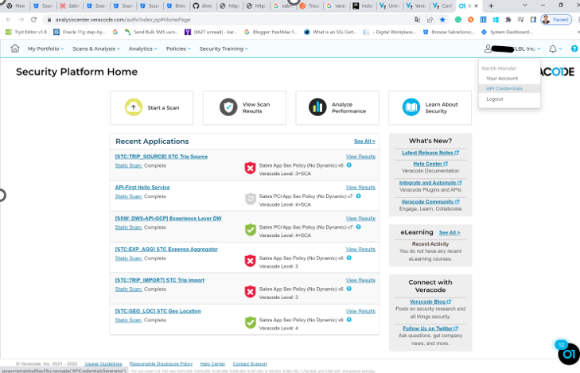

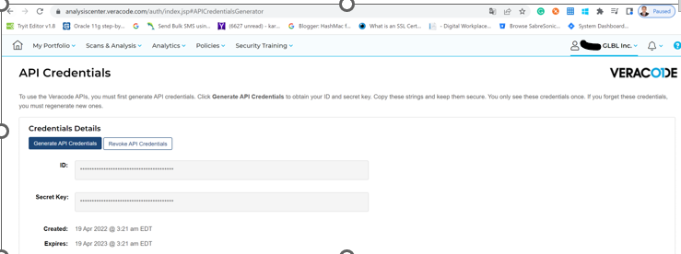

* 1. **Copy ID and Secret Key which is generated in step 3 and past in File 🡪 Settings 🡪 Veracode Greenlight 🡪 Store Credential Intellij 🡪 and save.**
  2. 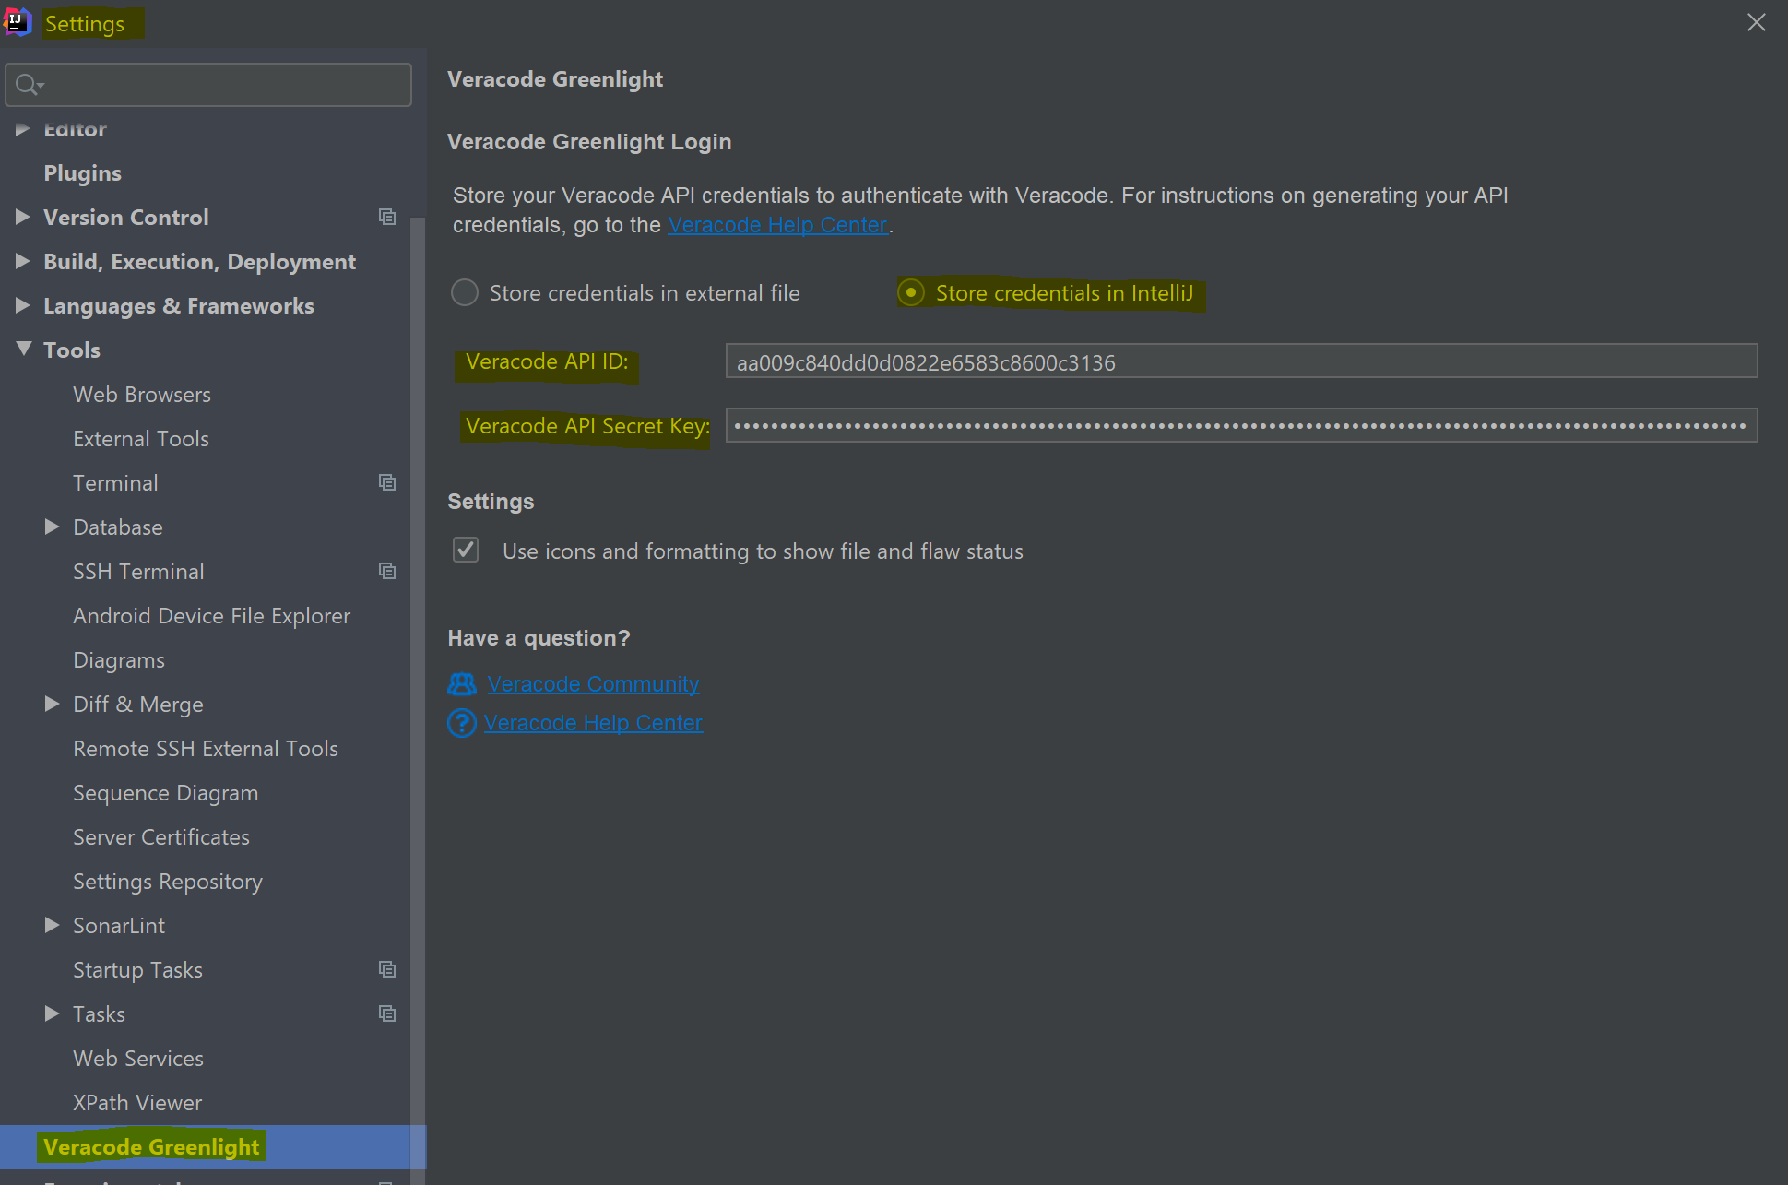
  3. **Compile : mvn sonar:sonar**

1. **SonarLint Setup**
   1. **First you need to plugin SonarLint : Step**



* 1. **Search SonarLint**
  2. **Install**
  3. **Restart the Intellij**
  4. **After restart: goto File 🡪 settings 🡪tools 🡪SonarLint 🡪Click ‘+’ 🡪Generate Token 🡪 Where key is ‘Token’ 🡪Copy the generated token data 🡪** and pest here 🡪 Done

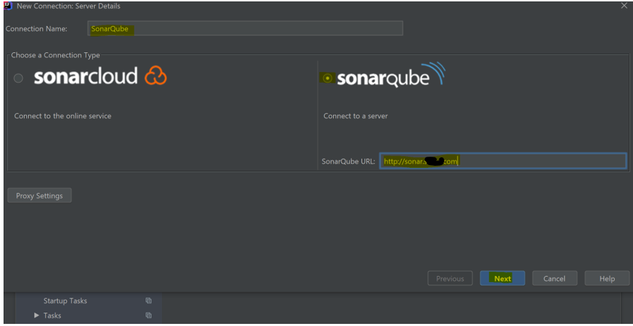

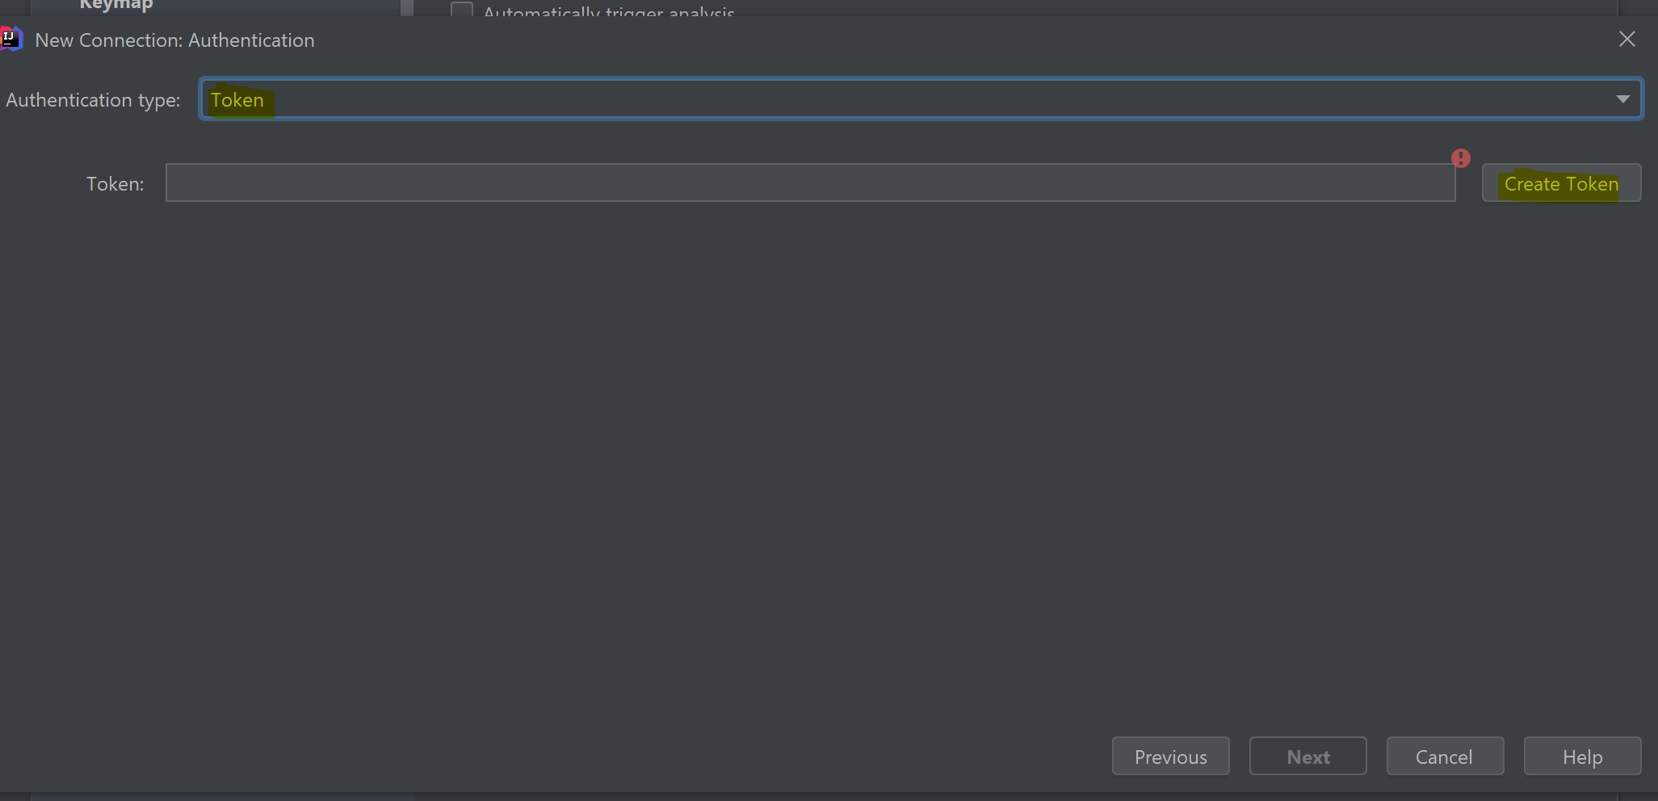

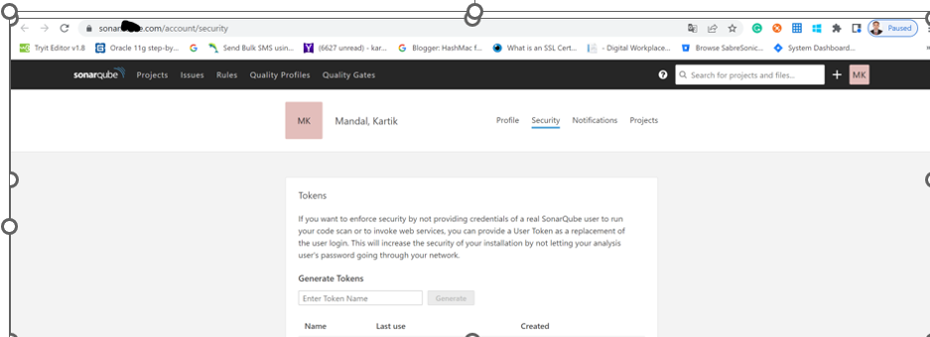

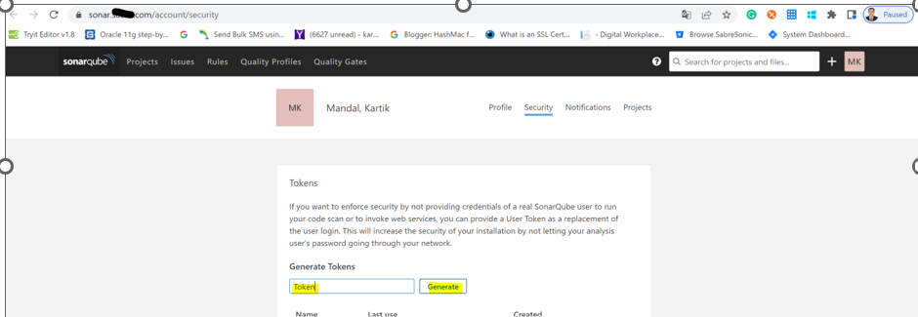

* 1. 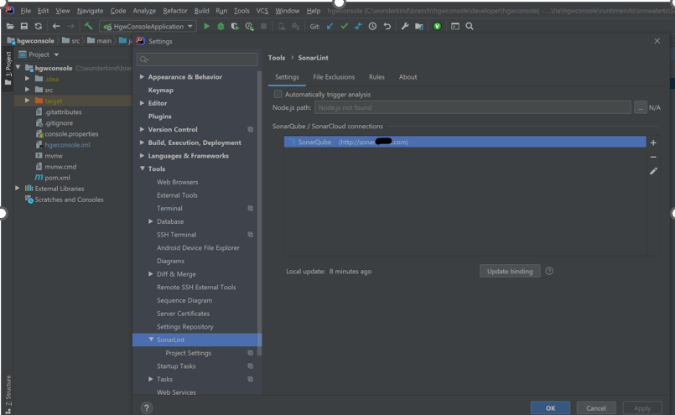
  2. **Compile : mvn sonar:sonar**